NHS services we provide:
Dispensing prescriptions
We dispense NHS prescriptions (paper and electronic) and will give advice on how to get the most benefit from your medicines. We keep a comprehensive stock of medicines and use a fast and an efficient wholesaler service to enable us to dispense all prescriptions promptly.
We can also dispense NHS repeat dispensing prescriptions. Ask us for more information about this service.
All medicines are dispensed in child resistant containers unless you ask us not to.
Please remember: keep all medicines out of the reach and sight of children. Our staff can advise you on safe storage of medicines.

Electronic Prescription Serviced (EPS)
At J & J Pharmacy Ltd, You can now receive your prescriptions electronically. This means when you have nominated us on EPS as your choice, your general practitioner’s surgery or clinic (GP can send your prescriptions electronically to our system. You just order your medicines as usual and inform us of the order then your prescription will electronically arrive at our pharmacy (please allow 2-3 days) and we will keep the prescribed medicines ready for you.
Unwanted medicines
Please return all unwanted medicines to the pharmacy where we will dispose of them safely.

Health advice and self-care
Our pharmacist and trained assistants are available to provide advice on all medicines and minor ailments, in private if required. We can also give you advice on how to live a healthy life, for example, advice on how to stop smoking or healthy diets. We can direct you to other sources of advice and assistance if we cannot help you ourselves.

New Medicine Service
When you are prescribed a medicine to treat a long-term condition for the first time, the pharmacist will support you to use the medicine safely and to best effect.
Our pharmacist will talk to you approximately two weeks after you first receive the medicine to see how you are getting on with it and to discuss any problems you may have. A second follow-up will be a month after you first receive the medicine. The service is only available to people using certain medicines. Our pharmacist will give you details and offer this free NHS service, if this is available to you.

Flu Vaccination Service
Each year we provide an NHS flu vaccination service to people aged 18 years and older who are eligible to receive a free vaccination. We can offer this flu vaccination to the non-eligible group for a fee. Ask us for more information about eligibility for this service.

Patient records
We keep records of all your prescriptions dispensed by us as well as records of other services we provide to you. This helps us check for possible problems, such as reactions between medicines and will help us deal with any queries you may have.
We comply with the Data Protection Act and the NHS code on confidentiality. If you want to discuss the records we keep, please speak to a member of staff.

We provide the above NHS services on behalf of:
NHS England, PO Box 16738, Redditch, B97 9PT
england.contactus@nhs.net
Other services we provide:
Prescription ordering service
We offer a free ordering service from selected local general practices and we can also deliver prescriptions to your home. Ask us for more information about this service.
Medicines sales
We keep a wide range of over the counter medicines and related products. Our staff members can help you to select the most appropriate products for your needs.
Emergency Hormonal Contraception
Free emergency hormonal contraception is available to all women through the Patient Group Directive.

Holiday healthcare
We can advise on medical requirements for travellers, including anti-malaria medicines.

Emergency supplies
If you need one of your regular prescribed medicines in an emergency, when you are unable to contact your doctor, we may be able to help. This can only be done in genuine emergencies and it may incur a charge.

Questions, comments, suggestions and complaints
If you would like more information about any of the services we provide, please ask a member of staff or telephone the number on the front of this leaflet.
Our aim is to give the highest possible standard of service. We would like you to tell us what you think about the service we provide at this pharmacy and any suggestions of ways in which we can improve our services to you.
If you have any comments, suggestions or complaints, please speak to a member of staff.
We operate a complaints procedure as part of the NHS system for dealing with complaints. Our system meets national criteria. Our pharmacist will give you further information about this.
Access for people with disabilities
We have ample off-road parking space outside. We also have extra wide front plus ramp and to enable wheelchair access.
Want to speak in private?
We have a consultation room available (with extra wide door for wheelchair access) if you’d like to discuss something in private. Just ask a member of staff to speak in private.

When we are closed…
When the pharmacy is closed, if you urgently need medical help or advice, but it’s not a life-threatening situation, contact NHS 111, by calling 111. Information can also be accessed at www.nhs.uk.

Threats of violence or abuse of our staff

Our staff work hard to provide you with the best possible service. Please treat them with the courtesy and respect they deserve.
We may refuse to provide services to individuals or those accompanying those individuals who are violent, threaten violence, commit or threaten to commit a criminal offence.

This pharmacy is owned by:
Mr Po Ming Yau
177, Bath Road
Worcester WR5 3AQ
Tel: 01905 354651


J & J Pharmacy Ltd

Address: 177, Bath Road
Worcester, WR5 3AQ
Tel: 01905 354651
Email: pharmacy.fv426@nhs.net

Opening Hours


Mon – Fri: 9.00am – 5.30pm
Sat: 9.00am – 12.00pm
Sun: CLOSED

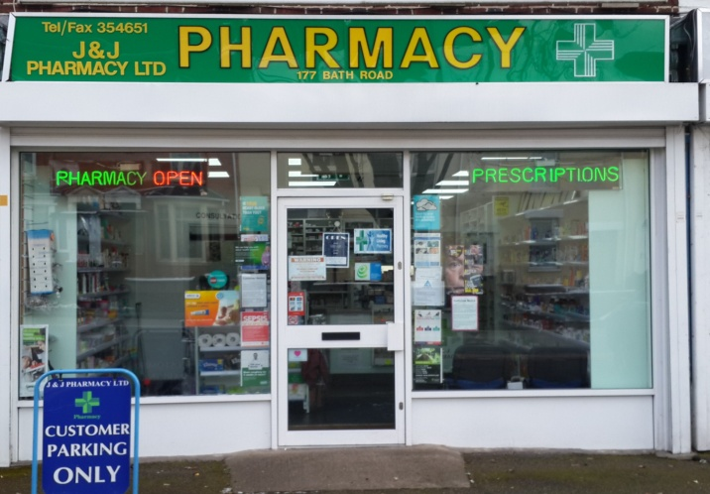

As your local community pharmacy, we can offer a wide range of services for you and your family. This leaflet provides information about our services.

